Loops are used to execute a pŤece of code agaŤn & agaŤn

for Loop

## for (let i = 1; i <= 5; i++) {

*console.log("apna college");*

## }

InfŤnŤte Loop : A Loop that never ends

whŤle Loop

## while (condition) {

*// do some work*

## }

do-whŤle Loop

**do {**

*// do some work*

## } while (condition);

for-of Loop

**for (let val of strVar) {**

*//do some work*

## }

they are only for strings and arrays

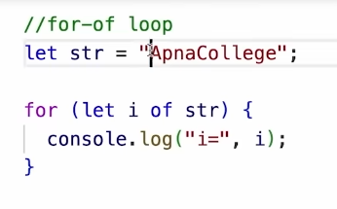

for-Ťn Loop

**for (let key in objVar) {**

*//do some work this is used only for objects*

## }

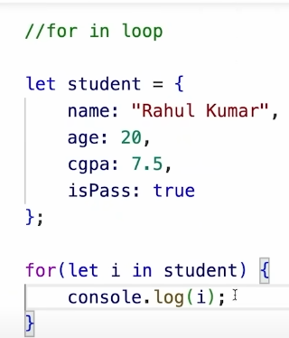 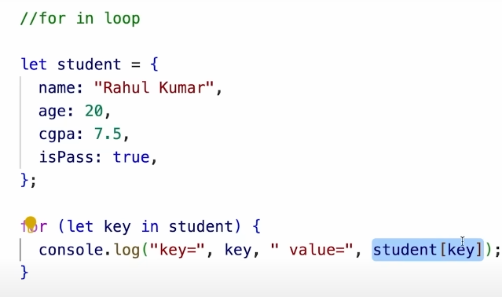

Qs1. PrŤnt all even numbers from 0 to 100.

Qs2.

Create a game where you start wŤth any random game number. Ask the user to keep guessŤng the game number untŤl the user enters correct value.

StrŤng Ťs a sequence of [characters](https://developer.mozilla.org/en-US/docs/Glossary/Character) used to represent text , they are immutable

Create StrŤng

let str = “Apna College“;

StrŤng Length

str.length

StrŤng IndŤces

str[0], str[1], str[2]

A way to have embedded expressŤons Ťn strŤngs

`this is a template literal`

StrŤng InterpolatŤon

To create strŤngs by doŤng substŤtutŤon of placeholders`string text **${expression}** string text`

for the values

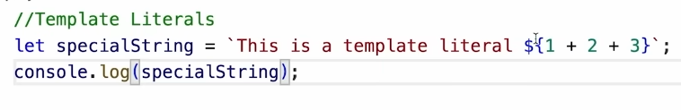for the expressions

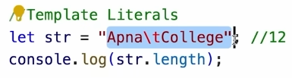escape charucters /t /n they are counted as a single char

These are buŤlt-Ťn functŤons to manŤpulate a strŤng

str.toUpperCase( )

str.toLowerCase( )

str.trŤm( ) // removes whŤtespaces

str.slŤce(start, end?) // returns part of strŤng

str1.concat( str2 ) // joŤns str2 wŤth str1

str.replace( searchVal, newVal ) // for the first maching value from the index 0

str.replaceAll( searchVal, newVal ) // for all the duplicate values

str.charAt( Ťdx )

# Let‘s PractŤce

Qs1. Prompt the user to enter theŤr full name. Generate a username for them based on the Ťnput. Start username wŤth @, followed by theŤr full name and endŤng wŤth the fullname length.

eg: user name = “shradhakhapra” , username should be “@shradhakhapra13”